**EXPERIMENT NO 7 NAME –** Pravin Patil

**CLASS-** TE - A

**ROLL NO** - 3138

**TITLE**- Study of different wireless network components and features of any one of the Mobile Security Apps [AVG]

**INTRODUCTION:**

**AVG** AntiVirus (previously known as AVG, an abbreviation of Anti-Virus Guard) is a line of antivirus software developed by AVG Technologies, a subsidiary of Avast, a part of Gen Digital. It Includes a limited amount of security features: Stops viruses, ransomware, spyware, and other malware. Blocks unsafe links, downloads, and email attachments.

# FEATURES:

* [**Malware scanning**](https://cybernews.com/best-antivirus-software/avg-antivirus-review/#malware-scanning)plenty of scanning options available with AVG Antivirus.
* [**Real-time protection**](https://cybernews.com/best-antivirus-software/avg-antivirus-review/#real-time-protection) – continuously scans your system in the background.
* [**Phishing protection**](https://cybernews.com/best-antivirus-software/avg-antivirus-review/#phishing-protection)– keeps you safe from phishing attacks.
* [**Enhanced firewall**](https://cybernews.com/best-antivirus-software/avg-antivirus-review/#firewall) – monitors incoming and outgoing network traffic.
* [**Network Inspector**](https://cybernews.com/best-antivirus-software/avg-antivirus-review/#network-inspector) – monitors your home or public network from vulnerabilities.
* [**Web and email shield**](https://cybernews.com/best-antivirus-software/avg-antivirus-review/#web-shield) – secures you while browsing and sending email attachments.
* [**Secure browsing**](https://cybernews.com/best-antivirus-software/avg-antivirus-review/#secure-browser) – protects your private data while browsing online.
* [**Anti-theft phone tracker**](https://cybernews.com/best-antivirus-software/avg-antivirus-review/#h-anti-theft-phone-tracker) – secures your devices if you lose it or it gets stolen.
* [**Sensitive data shield**](https://cybernews.com/best-antivirus-software/avg-antivirus-review/#sensitive-data-shield) – protects sensitive files from hackers.
* [**Webcam protection**](https://cybernews.com/best-antivirus-software/avg-antivirus-review/#webcam-protection) – controls access to your webcam.
* [**AVG AntiTrack**](https://cybernews.com/best-antivirus-software/avg-antivirus-review/#avg-antitrack) – prevents website trackers from collecting your data.
* [**AVG Secure VPN**](https://cybernews.com/best-antivirus-software/avg-antivirus-review/#avg-secure-vpn) – makes your private data anonymous online

# PLATFORM SUPPORT

AVG provides AVG AntiVirus Free for [Windows](https://en.wikipedia.org/wiki/Windows), AVG AntiVirus for Mac for [macOS](https://en.wikipedia.org/wiki/MacOS) and AVG AntiVirus for Android for [Android devices](https://en.wikipedia.org/wiki/Android_device). All

are [freemium](https://en.wikipedia.org/wiki/Freemium) products: They are free to download, install, update and use, but for technical support a premium plan must be purchased.

AVG stopped providing new features for Windows XP and Windows Vista in January 2019. New versions require Windows 7 or later; virus definitions are still provided for previous versions.

**AVG Setup**

|  |  |
| --- | --- |
| AVG’s setup is roughly the same as any other major antivirus software on the market today. | |
| **Step 1:** | Download the installation file from the AVG website. |

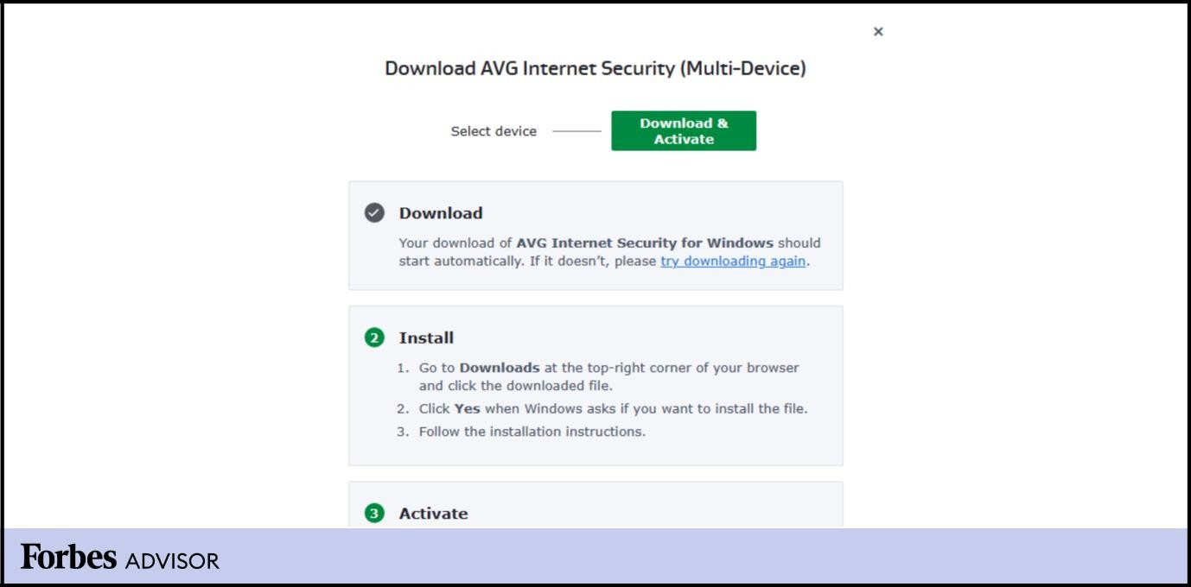

|  |  |
| --- | --- |
|  | Run the installation file. |
| **Step 2:** |

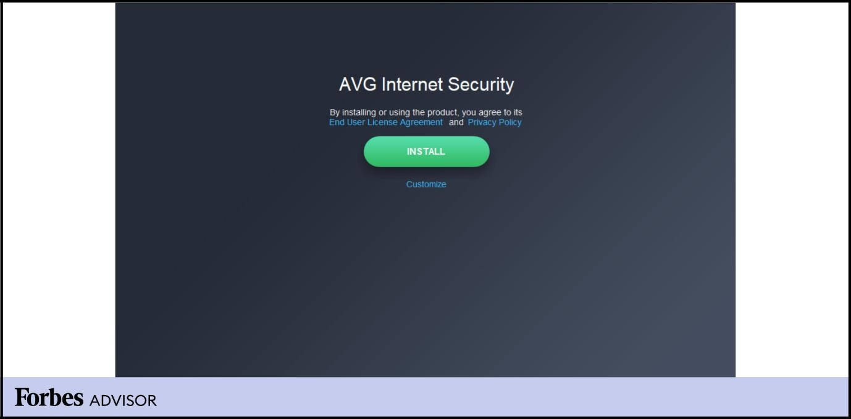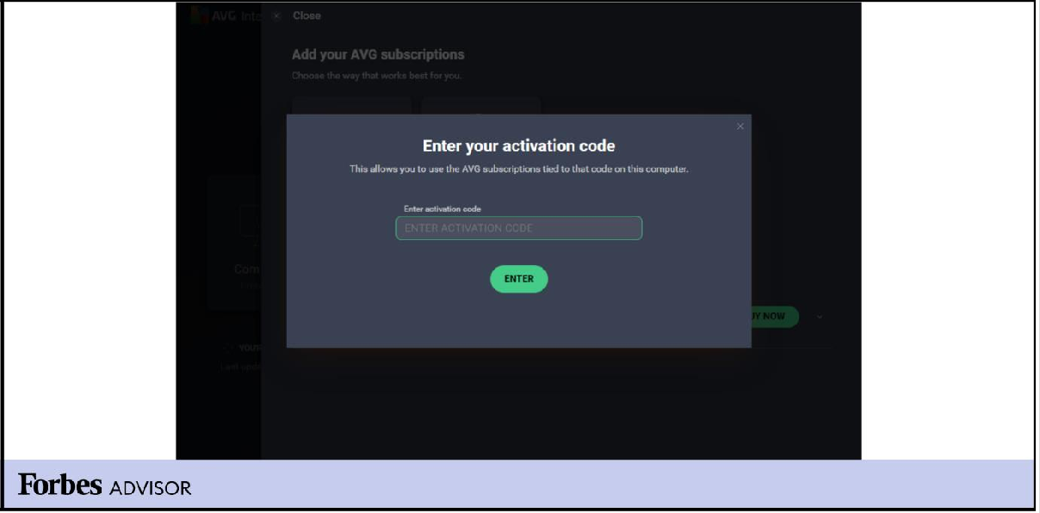

Input the activation code found on your AVG account page

Step 3:

# IMAGES

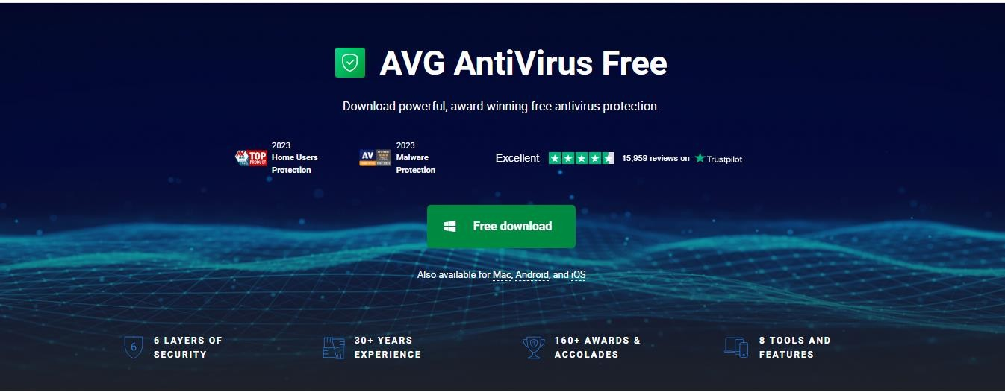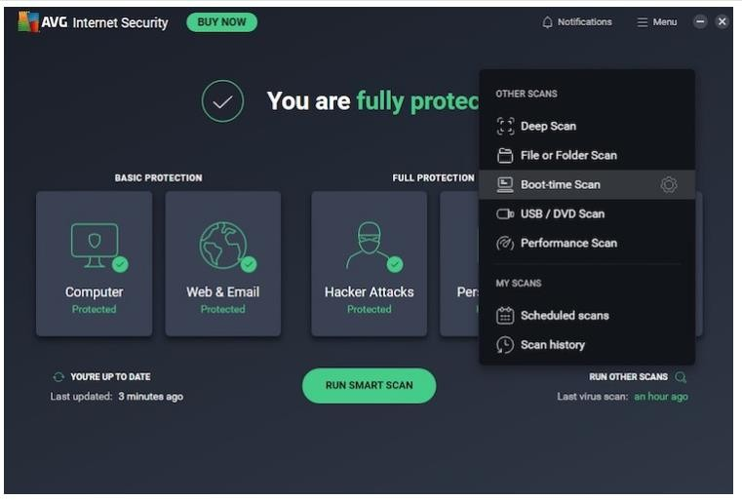

**CONCLUSION:**

I Studied about the mobile security app AVG .